LUNAR CORROSION  PERSONAL PROTECTIVE EQUIPMENT PROGRAM  CONTROL LLC | Date:  2019 | Department:  Safety Department
 |  | Approved by: Management

Table of Contents

Page

- Purpose and Scope ……………………………………………………… 1
- References ……………………………………………………………… 2
- Hazard Assessment ……………………………………………………… 2
A) Need for Personal Protective Equipment ……………… 2
B) Selection of Personal Protective Equipment ……………… 3
C) Site Reassessment of Safety Hazards ……………………… 3
- Employee Training ……………………………………………………… 4
- Cleaning and Maintenance ……………………………………………… 4
- Personal Protective Equipment – Specific Information ……………… 5
A) Eye Protection ……………………………………………… 5
B) Hearing Protection ……………………………………… 6
C) Head Protection ……………………………………………… 6
D) Protective Footwear ……………………………………… 7
E) Skin Protection ……………………………………………… 8
F) Respiratory Protection ……………………………………… 9
G) Hand Protection ……………………………………………… 9
H) Safety Belts, Lifelines and Lanyards ……………………… 10
I) Working Over or Near Water ……………………………… 11

I. PURPOSE AND SCOPE
Upon the basis of the hazard assessment, Lunar provides personal protective equipment (PPE) for eyes, face, head, and extremities, protective clothing, respiratory devices, and protective shields and barriers to aid in protecting the employee from hazards that may occur at Lunar. Note PPE is used as one means to control the hazards to the employee. It should not be relied on to provide protection against hazards, but should be used in conjunction with guards, engineering controls, and sound manufacturing practices. The purpose of this section is to explain to each employee who is required to use PPE to know the following:

- When PPE is necessary;
- What PPE is necessary;
- How to properly don, doff, adjust, and wear PPE;
- The limitations of the PPE, and;
- The proper care, maintenance, useful life and disposal of the PPE.

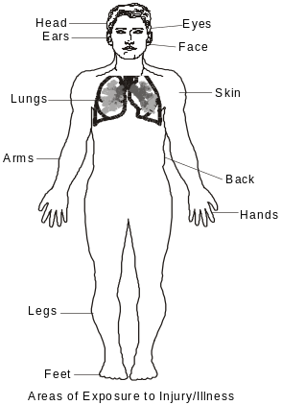
Lunar requires each affected employee to demonstrate an understanding of the requirements for the PPE, and the ability to use PPE properly, before being allowed to perform work requiring its use.

II. REFERENCES
29 CFR 1910.132 – 139 Personal Protective Equipment
Lunar Corrosion Control LLC Respiratory Protection Program
Lunar Corrosion Control LLC Hearing Conservation Program
29 CFR 1926 Subpart E
Lunar Corrosion Control LLC Fall Protection Program
Lunar Corrosion Control LLC Water Safety Program

III. HAZARD ASSESSMENT

A. In order to assess the need for PPE, the following steps are taken:

- The Site Safety Supervisor and/or Project Supervisor will conduct a site survey of the work environment where hazards may be. The survey will be documented on the Job Safety Analysis (JSA) form. Consideration is to be given to the basic hazard categories:
- Impact
- Penetration
- Compression
- Chemical
- Heat
- Harmful Dust
- Light (optical) Radiation
- Hazardous atmosphere

Generally, PPE will consist of equipment to provide protection against the major parts of the body. Some areas of injury would consist of the eyes, skin, head, face, ears, respiratory, feet, arms, fingers and other extremities as shown below.

- Following the survey the Site Safety Supervisor and/or Project Supervisor will organize the data and information for use in the assessment of hazards to analyze the hazards and enable proper selection of protective equipment.

- An estimate of the potential for injuries is now made. Each of the basic hazards viewed and a determination made as to the type, level of risk, and seriousness of potential injury from each of the hazards found.

- The JSA documents the hazard assessment via a written certification that identifies the recognized work site hazards.

B. Selection of Personal Protective Equipment is to:

- Become familiar with the potential hazards and the type of protective equipment that are available, and what they can do.

- Compare the hazards associated with the environment.

- Select the PPE which ensures a level of protection greater than the minimum required to protect employees from the hazards, and

- Fit the user with proper, comfortable, well fitting protective device and give instructions on care and use of the PPE. It is very important that the users are aware of the warning labels for and limitations of their PPE.

C. Site Reassessment of Safety Hazards

It is the responsibility of the Site Safety Supervisor/ Project Supervisor to reassess the work site hazard situation as necessary, to identify and evaluate new equipment and processes, to review accident records, and reevaluate the suitability of previously elected PPE.

Elements which should be considered in the reassessment include:

- Adequacy of the PPE program
- Accidents and Illness experience
- Levels of exposure
- Adequacy of equipment selection
- Number of person-hours that workers wear various types of protection
- Adequacy of training/fitting of PPE
- Program Costs
- Adequacy of program records
- Recommendation for program improvement and modification
- Coordination with overall safety and health programs

- EMPLOYEE TRAINING

- The Safety Department and/or office safety representatives will provide training for each employee who is required to use personal protective equipment. Training includes:

- When PPE is necessary
- What PPE is necessary
- How to Wear assigned PPE
- Limitations of PPE
- The proper care, maintenance, useful life, and disposal of assigned PPE
- Employees must demonstrate an understanding of the training and the ability to use the PPE properly before they are allowed to perform work requiring the use of the equipment.

- Employees shall not perform work without donning appropriate PPE to protect them from the hazards they will encounter in the course of that work.

- If the Site Safety Representative, Project Supervisor, Office Safety Representative and/or the Safety Department reason to believe an employee does not have the understanding or skill required, Lunar Corrosion Control LLC must retrain. Circumstances where retraining may be required include changes in the work site or changes in the types of PPE to be used which would render previous training obsolete. Also, inadequacies in an affected employee’s knowledge or use of the assigned PPE, which indicated that the employee has not retained the necessary understanding or skills.

- The Safety Department or Office Safety Representative will certify in writing that the employee has received and understands the PPE training.

V. CLEANING AND MAINTENANCE

- It is important that al PPE be kept clean and properly maintained by the employee to whom it is assigned. Cleaning is particularly important for eye and face protection where dirty or fogged lenses could impair vision. PPE is to be inspected, cleaned and maintained by employees at regular intervals as part of their normal job duties so that the PPE provides the requisite protection. Supervisors are responsible for ensuring compliance with cleaning responsibilities by employees.

- The Site Safety Representative and/or Project Supervisor will maintain PPE that is for general use. If the piece of PPE is in need of repair or replacement, it is the responsibility of the employee to bring it to the immediate attention of his or her supervisor. It is against work rules to use a piece of PPE equipment that is in disrepair or not able to perform its intended function.

- Contaminated PPE, which cannot be decontaminated, is to be disposed of in a manner that protects employees from exposure to hazards.

VI. PPE – SPECIFIC INFORMATION

A. Eye Protection
Work at Lunar and in the field can subject an employee to various hazards to their eyes. The major hazards to employee's eyes are exposure to foreign objects. There is also a potential for impact hazards and chemical exposure to an employee's eyes if they engage in certain types of work. The potential for the hazard of having a chemical or other foreign objects getting in your eye varies from the type of work. Subsequently, the type of eye protection required also varies depending on the type of work the employee is conducting. Eye protection is required for any individual in the facilities, field and laboratories. Obviously, eye protection is not required in the offices. The following describes the various types of eye protection available to employees of Lunar.

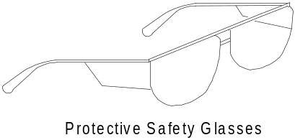1. Protective Safety Glasses: This type of eye protection consists of glasses that include side shields that will provide limited protection to a person from a small incidental splash that could occur to one’s eyes. Many of the glasses also provide protection from impact such as a foreign object thrown from an operating machine like a circular saw. This type of eye protection provides the minimal protection for your eyes. The safety glasses do not seal around ones face failing to provide protection from the potential of materials running down into your face and eyes (vapors, chemicals and dust).

2. Safety Goggles: Safety goggles fit tightly to your face and surround the eye area to provide a higher degree of protection than safety glasses.
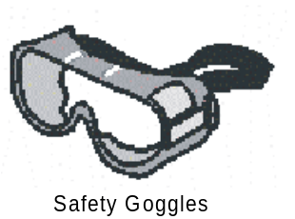
Since the goggles seal around your face, they will provide better protection from dust, splashing chemicals or vapors that may run down your face and into your eyes. Some goggles will have problems of fogging since they seal around the face. This situation would require a splash goggle that has an indirect vent to prevent splashing to occur in the vent. The indirect vent should be used in place of the normal vented goggles (numerous small holes around the perimeter). If the hazard to your eyes is from fumes, non-vented goggles must be used. Padded goggles are another option. These may be used in the area of exposure to a nuisance dust.

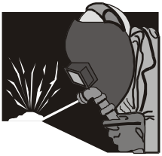3. Full Face Shields: Full Face Shields give protection to the entire face. A full-face shield should be used in areas of welding, chemical exposure or anytime more protection is needed for both the eyes and face. The areas where welding takes place, a welder’s face shield must be used (make sure the proper tinting is used for that area).

B. Hearing Protection. (Reference Lunar Corrosion Control LLC Hearing Conservation
Program)
Normal work at Lunar does not subject an employee to occupational noise exposure over the sound levels established in 29 CFR § 1910.95, which requires a hearing conversation program and/or hearing protection. However, there are some operations, out in the field or areas in the plants where hearing protection required. In those situations, Lunar (or customer site) will provide the employee with the appropriate protection. The different types are described below:

- Ear Plugs: Earplugs are soft plugs designed to fit in and expand in your ear canal. Styles vary from straight plugs to “ez-fit” bell shaped to corded ones. The plugs work by inserting them into your ear canals and allowing them to expand out. The plugs should not be re-used after you remove them from your ear.
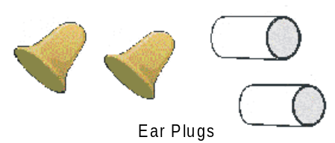
- Earmuffs: Earmuffs are another form of hearing protection. Earmuffs will complete encapsulation of the ear. Muff usually have a lower noise reduction rating than plugs.

C. Head Protection
Lunar has identified that some work can subject employees to injuries to their head from impact, electrical shock, bump, burn or laceration. The potential for the different types of injuries varies from working conditions. The type of head protection required by Lunar is: Hard Hat

- Hard Hat Working Areas: This working area would be an area where work is being performed and a person is subject to falling or flying objects; or electrical equipment where a person may receive an electric shock on the head; or elevated hot works where falling or flying sparks are present.
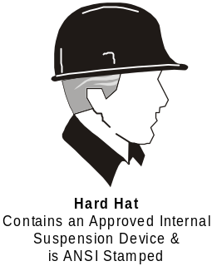
The type of head protection is described below:

- Hard Hats. Hard hats have a large suspension system and are stamped with the ANSI markings. Hard hats shall comply with American National Standards Institute (ANSI) Standard ANSI Z89.1-1986, “American National Standard for Personnel.”

D. Protective Footwear.
The Safety Manager has identified that work with Lunar can subject an employee to injuries to their feet due to hazards such as, but not limited to, falling objects like an anode. The exposure is to any employee working in the facility and thus all facility employees are required to have some type of protective footwear that protects them from impact. The type of protective footwear shall comply with American National Standards Protection—Protective Footwear.” The footwear should be steel tipped at the toes.

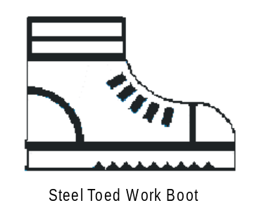
E. Skin Protection
Since, the work with Lunar involves many different situations there is the possibility of hazards to your skin. When there is the exposure of the materials to ones skin, the proper type of personal protective equipment is required. Some types of PPE for skin protection consists of the following:

1. Coveralls, Splash Suits, Arm Protectors Spats, and FRC’s
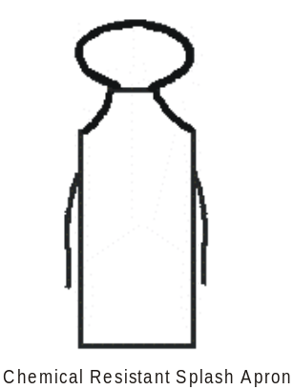Coveralls, splash suits, arm protectors and spats are designed to be worn over your normal clothing to give one protection from chemical spills, heat or welding. These items are offered in various types and need to be resistant to your particular exposure. Some of the types available:

- Hooded coveralls
- Non-hooded coveralls
- Collared coveralls
- Level B splash suits
- Level A splash suits
- Booted (coverage over feet) coveralls
- Arm protectors
- Spats
- FRC’s

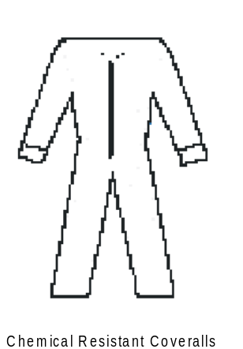The types of materials would consist of:

- Neoprene
- Tyvek
- PVC
- Polypropylene
- Aluminized thermal fabric
- Leather

Most employees will have adequate protection using a Tyvek suit for chemical exposure or leather clothing for heat and welding. Only Emergency Responders or some Confined Space Workers will have the need for Level A or B made of material like PVC.

Some protective clothing is perishable and will need to be replaced routinely.

2. Aprons: Aprons provide limited protection for employees with frontal exposure when working with materials. Aprons are beneficial when working with certain machines such as lathes.

- Respiratory Protection (Reference Lunar Corrosion Control LLC Respiratory
Protection Program)
There is the potential of hazards to ones respiratory system. Areas where this exposure is present a respirator must be worn. Lunar has developed a respirator protection program documented in the Standard Operating Procedure (S.O.P.) for Employee Respiratory Protection. This S.O.P. must be reviewed before any employee may wear any type of respiratory protection for Lunar. The S.O.P. describes the types of respiratory protection to be used and is summarized below:

Two different types of respirator parameters exist for selecting a respirator. These two parameters are respirator classification and the type of facepiece it uses. The classification of respirators is described below:

1. Air-Purifying Respirators (Negative Pressure): Air purifying respirators work by purifying the contaminated air before you breathe it by either filtering out particulates or removing contaminants through absorption in the filter. These types of respirators are limited to air that is not oxygen deficient (<19.5% O₂) and where exposure to toxic chemicals is low. You must match the proper filter for the particular contaminant that you are exposed to. That is, if you are exposed to an organic solvent like benzene, you need to use an organic vapor cartridge. However, this type of filter will not protect you from contaminants like ammonia.

2. Atmosphere Supplied Respirators (Positive Pressure): Air supplied respirators work by supplying you with a clean atmosphere to breathe. These types of respirators will work in oxygen deficient atmospheres and will work in heavily contaminated atmospheres.

a. There are two types of facepieces that are described below.

(1). Half-Mask: A half mask facepiece seals only over the lower half of your face by providing a seal around your nose bridge to your lower chin. These types of facepieces provide a protection factor of only 10, which is the lowest protection factor of the two types. By using the fit test with banana oil or bitter solution, the 10x protection factor can be confirmed by passing the test.

(2). Full-Facepieces: A full facepiece type seals both over the lower half of your face like the half mask, but also seals around the outer perimeter of your face yielding two face seals. The full facepiece types also provide eye protection. These types of facepieces provide a protection factor of 50. However, the 50x protection factor cannot be quantified by a fit test with irritant smoke.

G. Hand Protection.
Lunar requires employees to use appropriate hand protection when employee's hands are exposed to hazards such as those from skin absorption of harmful substances; severe cuts or lacerations; severe abrasions; punctures; chemical burns; thermal burns; and harmful temperature extremes. The selection shall be based on an evaluation of the performance characteristics of the hand protection relative to the task(s) to be performed, conditions present, duration of use, and the hazards and potential hazards identified.

- Chemical Resistant Gloves: Since the work will require the use of your hands, skin contact to your hands is great. The use of chemical resistant gloves is mandatory with any employee who will be handling chemicals. One needs to understand that the gloves must be resistant to chemicals. Leather, rubber or latex gloves are not resistant to chemicals and must not be used to handle chemicals. Additionally, no glove is universally resistant to all chemicals either. One needs to evaluate the material they will be using and make sure that they have the appropriate gloves. Examples include:
- Viton Gloves (most organic solvents)
- PVC Gloves (most organic solvents)
- Butyl Gloves (most organic solvents)
- Neoprene Gloves (most organic solvents and corrosives)
Gloves come in various styles such as tri-ply, flocked, lined, etc. Also, note that gloves are perishable, that is, they do not last forever. They can become worn, torn and ripped. Thus, one must routinely inspect their gloves to make sure that they are maintained properly and if not have them replaced.

- Thermal Gloves: Any employee working around welding, molten metal or hot objects are required to use a thermal resistant glove. Determining the type of glove that is needed depends on the temperature you're being exposed to. Examples include:
- Kevlar
- Leather
- Terry Cloth
- Aluminized
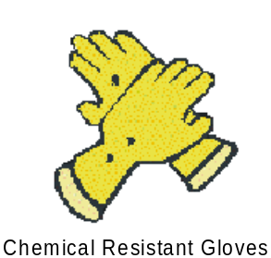
- Protective Gloves: Any employee working in areas that might be exposed to cuts, lacerations or hazards to the hands must wear protective gloves. These gloves will vary in different material. Always make sure the gloves are in good condition.

H. Safety Belts, Lifelines and Lanyards (Reference Lunar’s Fall Protection Program)

- Lifelines, safety belts, and lanyards shall be used only for employee safeguarding. Any lifeline, safety belt, or lanyard actually subjected to in-service loading, as distinguished from static load testing, shall be immediately removed from service and shall not be used again for employee safeguarding.

- Lifelines shall be secured above the point of operation to an anchorage or structural member capable of supporting a minimum dead weight of 5,400 pounds.

- Lifelines used on rock-scaling operations, or in areas where the lifeline may be subjected to cutting or abrasion, shall be a minimum of 7/8-inch wire core manila rope. For all other lifeline applications, a minimum of 3/4-inch manila or equivalent, with a minimum breaking strength of 5,400 pounds, shall be used.

- Safety belt lanyard shall be a minimum of 1/2-inch nylon, or equivalent, with a maximum length to provide for a fall of no greater than 6 feet. The rope shall have a nominal breaking strength of 5,400 pounds.

- All safety belt and lanyard hardware shall be drop forged or pressed steel, cadmium plated in accordance with type 1, Class B plating specified in Federal Specification QQ-P-416. Surface shall be smooth and free of sharp edges.

- All safety belt and lanyard hardware, except rivets, shall be capable of withstanding a tensile loading of 4,000 pounds without cracking, breaking, or taking a permanent deformation.

I. Working Over or Near Water (Reference Lunar’s Water Safety Program)

- Employees working over or near water, where the danger of drowning exists, shall be provided with U.S. Coast Guard-approved life jacket or buoyant work vests.

- Prior to and after each use, the buoyant work vests or life preservers shall be inspected for defects, which would alter their strength or buoyancy. Defective units shall not be used.

- Ring buoys with at least 90 feet of line shall be provided and readily available for emergency rescue operations. Distance between ring buoys shall not exceed 200 feet.

- At least one lifesaving skiff shall be immediately available at locations where employees are working over or adjacent to water.

